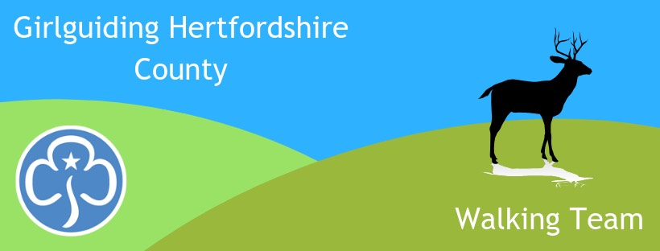
Girlguiding Hertfordshire
Follow us on Facebook for walking activities
www.facebook.com/hertsguideswalkingteam

Walking Team
Newsletter Jan 2022

The joy of walking is that it is outside; we enjoy blue sky, sunshine, the sound of birds & the wind in the trees, a stream trickling, and we can spot the first signs of Spring. Snowdrops are starting to open; have you noticed?

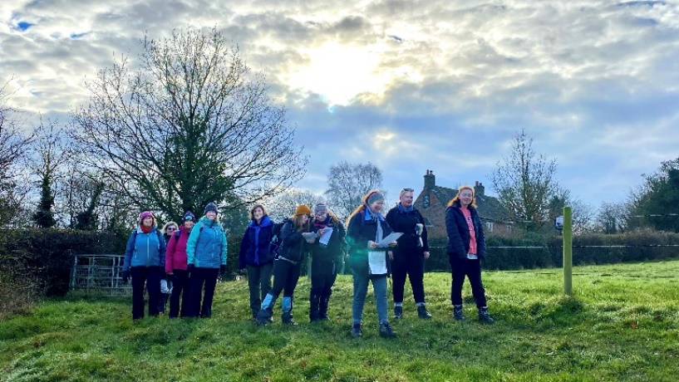
Last Sunday several of us really enjoyed the first social walk of the year. We had a few people practicing their navigation whilst other spotted deer tracks & red kites. The next social walk is Sun 6th Feb, from Debden Green, near Saffron Waldon – its quite a long one at 4.25 hours, details below. And for those adults who want more, a whole weekend away in the Black Mountains 18-20th March. We’ve held off booking accommodation due to Covid fears but now we need to know numbers in order to book somewhere the right size. Please reply NOW with an indication of interest.

Another great event that needs promoting now is Mountain Experience – a weeknd in the Peak District for Rangers & Young Leaders, (sleeping indoors in warm bunks and all food provided!) Its an opportunity to learn to navigate in Open Country, for DofE or for personal skills, or so that the girls can participate in Hertfordshire (Scouts) Peak Assault, a competitive navigation event. Again, please tell the girls about Mountain Experience NOW.

For younger ones we are offering a Sensory Safari for Rainbows & Brownies and Explore 3 for older Brownies & Guides. Both walking team activites are to be included in the County Outdoor Activity Day on 23rd April.

See below for details of these and other events. There’s something for everyone.

Alison Tuch, County Walking Adviser

Events Diary email walking@girlguidinghertfordshire.org.uk to book unless stated otherwise
29-30 January – Bronze/Silver DofE Training at Cherry Green Trees, London Colney. £50 to cover accommodation & food. Contact Katie Wright dofe@girlguidinghertfordshire.org.uk for more information.
Sunday 6th February – Social Walk from Debden Green, nr Saffron Walden. 9am – approx. 1.15pm. For adults, Young Leaders & Rangers. Bring a hot drink & several snacks. Just ‘walk & talk’ or improve your map reading skills if you wish – please say if you want this when booking. No charge.
5-6 March – 16 hour Outdoor First Aid course. ONLY ONE PLACE LEFT. For those needing a 16 hour first aid qualification in conjunction with other outdoor leadership qualifications eg: walking, DofE, climbing, cycling. Also useful for anyone wanting to learn a bit more than First Response. Will be based at Little Gaddesden (W Herts), but much of the course will be taught outside and all scenarios will be in Open Country. Course fee £130.
Saturday 5th March – Social Walk in Lea Valley, around the Sculpture Trail. Approx 2-4pm. For adults, Young Leaders & Rangers. Just ‘walk & talk’ or improve your map reading skills if you wish – please say if you want this when booking. No charge.
18-20 March – Adult Social Walking Weekend. Venue tbc, in the Black Mountains. Low cost, bunkhouse style accommodation, shared transport. AN INDICATION OF INTEREST IS NEEDED NOW.
1-3 April DofE Expedition Weekend in the Chilterns. £30. Contact Katie Wright dofe@girlguidinghertfordshire.org.uk for more information. Note there are several other possible exped dates so contact Katie if interested in doing DofE through Girlguiding.
Saturday 23rd April - Sensory Safari for Rainbows & Brownies and Treasure Hunt (Explore 3) for older Brownies & Guides. Both walking team activites to be included in the County Outdoor Day. £15. More information on the County website events page.
29th April – 2nd May - Introduction to the Hills. A camping weekend for Herts Guides and Scouts, aged 11 - 13, at The Foundry Adventure Centre in the Peak District. Activities include hill walking, outdoor climbing, cycling and caving. Cost: £140 (includes food and transport). Guides can attend without their leaders. email itthherts@gmail.com for further information and an application form.

Sunday 8th May – Social walk from Bramfield. For adults, Young Leaders & Rangers. 10.30-12.30. Just ‘walk & talk’ or improve your map reading skills if you wish – please say if you want this when booking. No charge.
10-12 June - Anglia Region Adult Social Walking Weekend in Shropshire – low cost, shared transport. Register your interest with Verity MacLachlan walking@girlguiding-anglia.org.uk
Saturday 18th June – Afternoon - Social geocaching in central Herts. For adults, Young Leaders & Rangers. Training and advice available. Please say if you want training when booking. No charge.
8-10 July - Mountain Experience, at Glenbrook Guide Centre, Peak District. A hillwalking weekend for Rangers & Young Leaders wanting to learn map reading & navigation skills for their own adventures, for DofE, or so that they can enter the Hertfordshire Scouts Peak Assault competition in remote terrain. £70 to include minibus transport, warm indoor bunk bed accommodation and food.
26-31 Aug - Anglia Heads High. A hill/mountain weekend in Crainlarich, Scotland for adults. £17/night or £75 for 5 nights. Option to self cater or pay £10 per day. Own travel. Email Moira Ledbetter moiledie@yahoo.co.uk for more information / to book.

Final Note:
Spring is coming. Why not challenge your girls to walk another Marathon? Or to do their first one? We have plenty of badges in stock. Just walk, run or use a wheelchair to complete 42km over as many sessions as it takes. 2-3km a day soon adds up. You can carry on if you wish and earn the next 4 badges to make up the 5 Olympic rings. Check the website for details:
https://www.girlguidinghertfordshire.org.uk/get-involved/challenge-badges/#marathon

