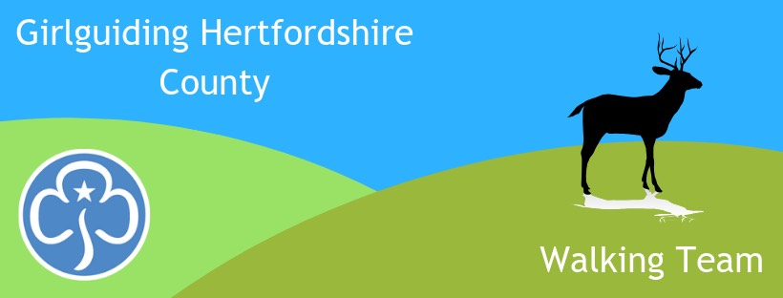
Girlguiding Hertfordshire
Follow us on Facebook for walking activities
www.facebook.com/hertsguideswalkingteam

Walking Team
Newsletter Nov 2021

STOP PRESS! – National HQ is funding our next Level 1 Walking Scheme course!

We will be running it 4th-5th December at Ellesborough Guide Centre, just over the border in Bucks, on the edge of the Chilterns. It will be fully catered and residential in bunk rooms and the cost to participants will be just £20!

This two day course is great for boosting the skill set and confidence of Leaders & Young Leaders aged 16+ who’d like to take their girls on more outdoor adventures, but just havent quite got the confidence to do so. The course will include map reading, compass & navigation skills, water safety (for canal /riverside or coastal walks, a few basic first aid scenarios and how to plan a walk including regulations such as which forms are needed and how to do a risk assessment.

This really is a golden opportunity for outdoor activity training and we promise you’ll have fun with like-minded people. So email Verity MacLachlan walking@girlguiding-anglia.org.uk to book your place or find out more.

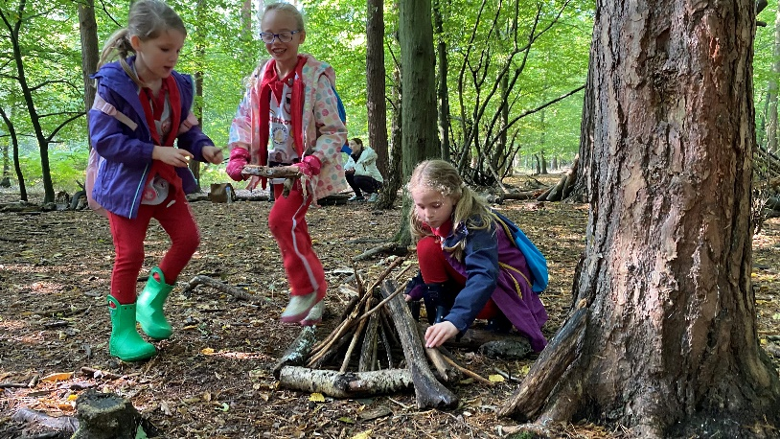
Meanwhile, Rainbows & Brownies have had lots of fun on our Sensory Safari in Broxbourne Woods. The sun shone and the girls loved building tiny fairy houses and bigger dens for themselves as well as using all their senses; listening to stories, smelling & tasting herbs, feeling bark and discovering optical illusions in the sculpture trail.

It was a very popluar event so if you missed it, we will be running it again in the Spring.

As previously reported, uptake for our Marathon Challenge badge to celebrate the Olympics far exceeded our expectations, so some unexpected profit has been made, which will be used to subsidise future walking events.

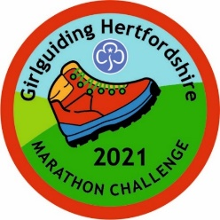
We do still have some badges remaining so if you havent ordered yours yet, or want to encourage your girls to do the challenge over the Chriastmas holidays, its not too late. Just walk, run or use a wheelchair to complete 42km over as many sessions as it takes. 2-3km a day soon adds up. You can carry on if you wish and earn the next 4 badges to make up the 5 Olympic rings. Check the website for details:
https://www.girlguidinghertfordshire.org.uk/get-involved/challenge-badges/#marathon

Enjoy your walking. See the events list on the next page.
Alison Tuch, County Walking Adviser

Walking Team Events email walking@girlguidinghertfordshire.org.uk to book
Friday 5th – Sunday 7th November – Anglia Region Adult Social Walking Weekend & Level 2 Walking Scheme Training. Now Full
Saturday 13th November – Social Walk on Devils’ Dyke & Nomansland –2.5 hour guided walk from 10am. For those aged 14+. Map reading skills help available – please say if you want this when booking. No charge
4-5th December - Level 1 Walking Scheme Training at Ellesborough Guide Centre, £20
Sunday 12th December – Social Walk from Wheathampstead to Batford Springs plus optional Christmas meal at The Bull –5.8mi or 9km, 2.5 to 3 hour guided walk, no charge. Lunch at own expense, limited places, must be pre-booked.
Sunday 16 January 10am – Social Walk venue tbc

